**Metal Corner Wall Shelves**

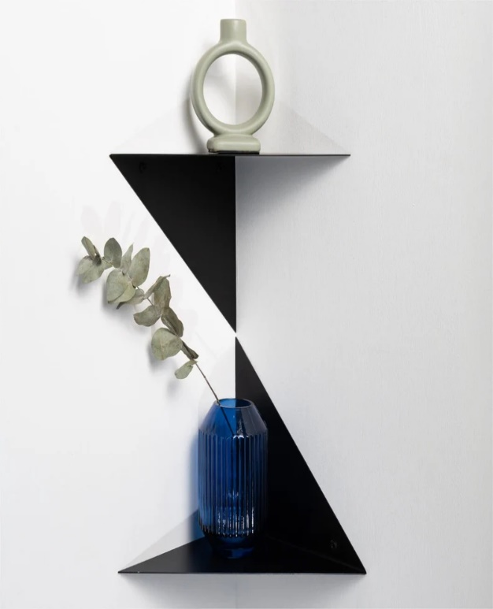Metal Corner Wall Shelves are a sleek and contemporary solution for utilizing corner spaces in your home or office. Made from durable metal, these shelves offer a sturdy platform for displaying books, plants, or decorative items while adding an industrial or modern flair to your décor. The metal construction ensures long-lasting strength, while the corner design maximizes unused space, making them ideal for tight areas. With various finishes, such as matte black, gold, or brushed silver, these shelves can complement a range of interior styles, from minimalist to urban chic. Their simple, functional design allows for easy installation, helping you keep your space organized and stylish.